Electric Field & Electric Potential

Notes:
- This one-week lab will be done face-to-face with your lab partners, in the Lab Room down in basement of LD.
- You will prepare a short summary on what you did and submit to your TA on (or before) the due date. Please see 'Summary_template.docx' for the format. Summaries are not as detailed as lab reports. Your TA might (not always) provide feedback which you should incorporate into your later lab reports and/or lab summaries. The short summary should discuss some (not all) elements mentioned in the handout “How will this lab be conducted?”.
- Turning in your summary:
  - Collaborate with your partners on data collection, analysis, and report.
  - Turn in only one summary but be sure it lists all group members as authors.
  - Lab reports and lab summaries should be uploaded to Canvas by the deadline in the course calendar.
  - Do not include raw spreadsheets in the reports or summaries. You may want to use figures in your report/summary that can contain snapshots of spreadsheet(s).
- Getting help:
  - Your lab TA can answer questions during the lab or after the lab by email or at their office hour (listed in the syllabus).
  - You can also ask advice from lab partner(s) and/or other students.

Objectives of this lab:

For this lab, you will ultimately draw (by hand or you may use a computer drawing application of your choice) the electric field lines and the electric equi-potentials in the region around two oppositely charged conductors.

These are things you will do:
- Using the probes and galvanometer you will uncover the electric equi-potential lines.
- Using the probes and galvanometer you will determine the electric field lines.
- Identify possible errors that can occur in your experiment.
- Minimize those errors.

What you will learn:
Please review the learning goals for the semester in lab in the handout from the first week. In addition, this lab has several specific goals:
- You will practice keeping lab notes in a paper notebook, computer file, or other format.
- You will enhance the data analysis skills you learned previously, by applying them to real data.
- You will learn to distinguish between two types of errors that occur in data: systematic errors and random errors.
- You will enhance your understanding of how noise arises in data, and how to account for that noise when interpreting experimental results.
- You will practice scientific communication skills by preparing graphs and writing a formal lab report.

What goes in my lab notes, and what about my report/summary?

The purpose of personal lab notes is to enable you or a colleague to reconstruct what was done and why.
- They don’t have to be neat, in complete sentences, etc., but they do have to be useful.
- In a case like this, they should include things like what as the setup.
- Did you try different setups or take multiple data sets for same setup?
- If you store multiple files, record what filenames correspond to what conditions.

The purpose of a report/summary is to explain what you learned and how you learned it. The sorts of things that belong here are
- A description of each step you did as part of the Activities.
- Any graphs or drawings to show to your results.
- Explain how you determined your results.
- Explain differences between calculated (theory) and the actual (measured) values.
- Your conclusions about any relevant and useful information you were able to extract.
- An analysis of the errors of the in your experiment.

EQUIPMENT

For this lab, the following are available for use: galvanometer (or multi-meter), two carbon-coated conducting sheets, copper tape, base-mounted metal probe, metal probe with handle, 1.5-volt battery, four patch cords.

DOs & DON’Ts
  - Don’t break the equipment – Take care using the base and handle metal probes.
  - Do consult with your Lab TA about the techniques you may want to consider as you design your particular experiment.
  - Don’t forget to record all data runs
  - Do use your imagination and have fun.

Sample Set-Up:

Background Information: The arrow direction for electric field lines points away from positive charges and toward negative charges. Charged conductors in electrostatic equilibrium have electric fields directed perpendicular to their surfaces. Why? (Discuss this in your Lab Summary.)

The electric equipotential lines are everywhere perpendicular to electric field lines. Galvanometers deflect away from zero whenever a potential difference exists between its posts. (Of course, there is no deflection whenever the posts are connected to any two points along the same equipotential.)

In this experiment, electric current flows along lines of electric field in the conducting sheets.

Suggested steps for each conducting sheet:

1) Attach a conducting sheet onto the Table.

2) Obtain 4 patch cords.

3) Run patch cords from each terminal of the battery to a post on the Copper tape. The post connected to the red terminal is positive.

4) Draw the conductor configuration on your grid paper. Indicate the positive and negative conductors.

5) Run patch cords between each metal probe and a post on the galvanometer.

6) Place the tip of the base-mounted probe at a point on the sheet at least 1 cm from one of the conductors. Locate 5 points that lie along the equipotential line, that is, move the probe with handle to 5 other positions where the galvanometer reads zero.

7) Avoid contact with the white dots, they do not conduct.

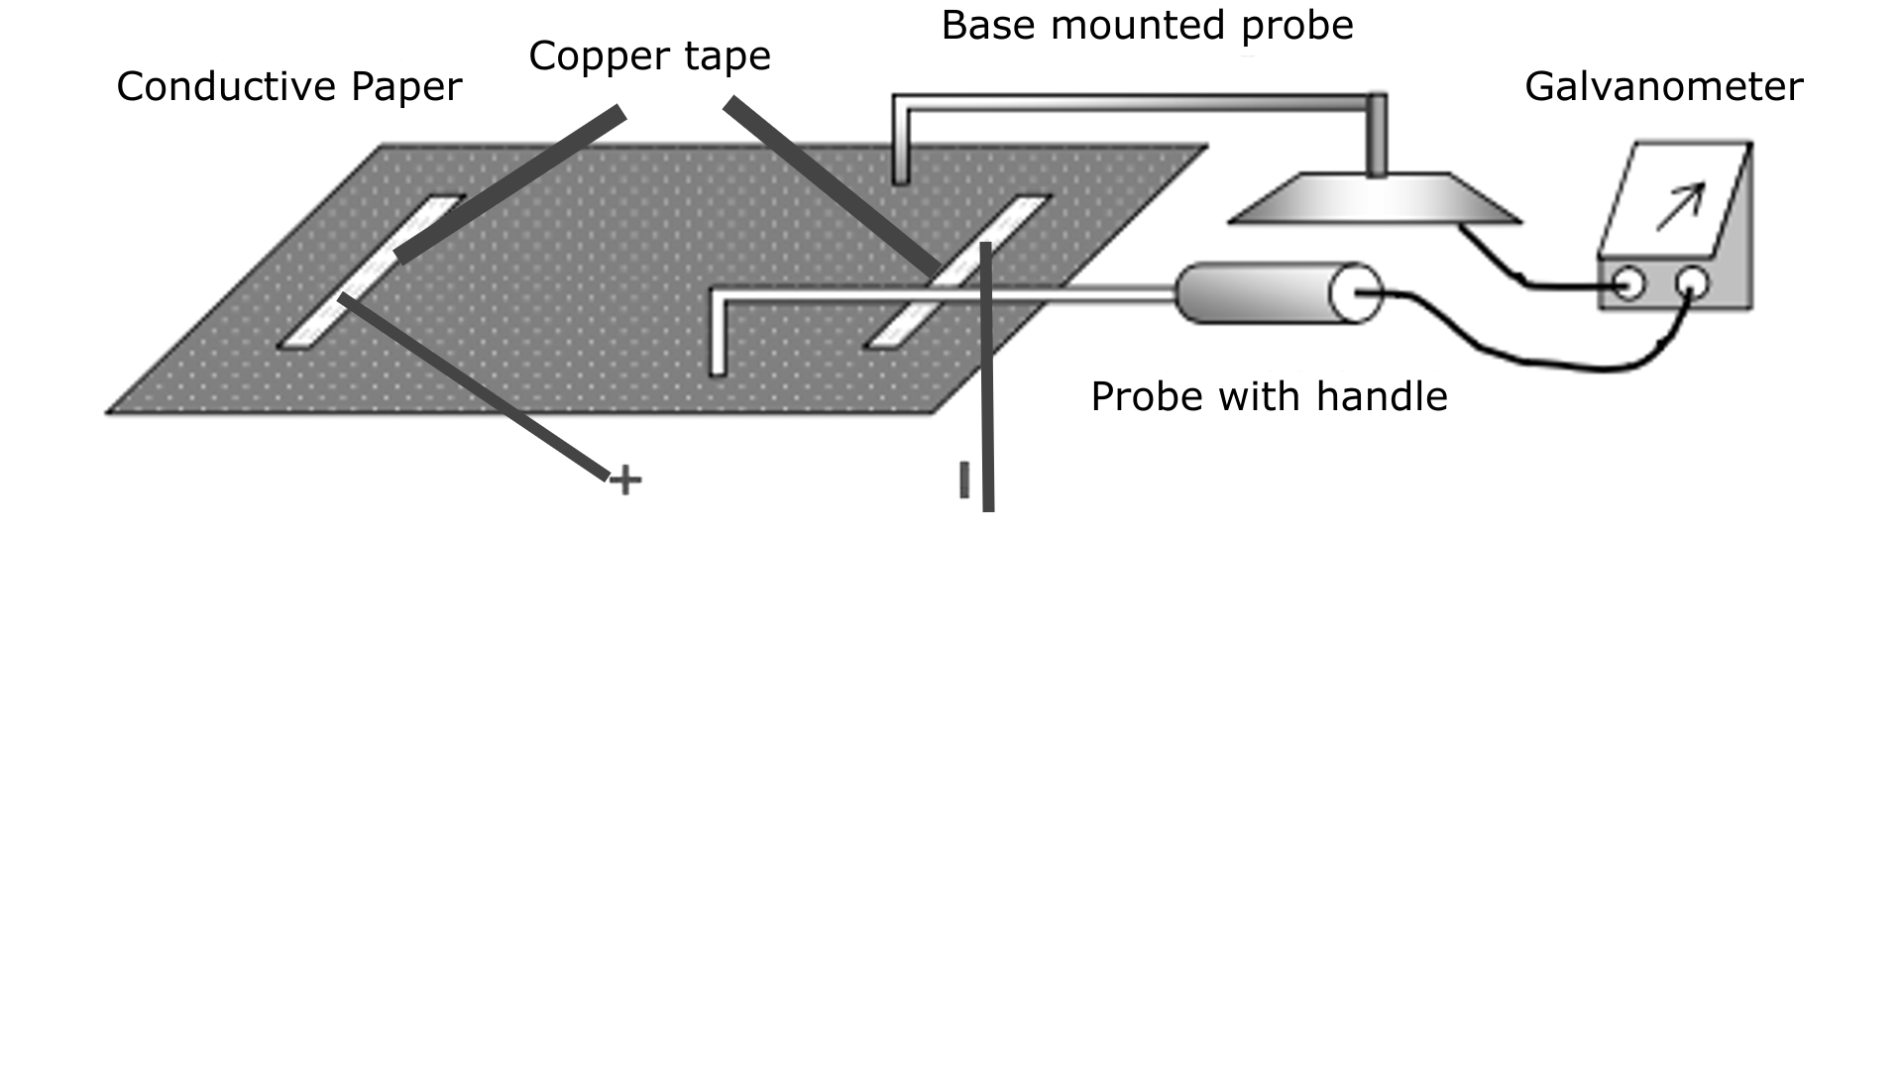

ACTIVITY: Investigating the Electric Field and the Electric Potential
- What can you say about the electric potential difference between any two points along the surface of a charged conductor in electrostatic equilibrium? Explain your answer in your summary.
- The electric field is zero everywhere inside a charged conductor in electrostatic equilibrium. Can you infer that the electric potential is everywhere zero? Explain your answer in your summary.
- If you probe the electric equi-potentials near the edges of the conducting sheets (not the conductors imprinted on the sheet), you will find that they are approximately perpendicular. Why? What does this tell you about the electric field (current) close to the edges? Explain your answer in your summary.
- If you increased the charge on the conductor bars (i.e, changed the battery voltage, say 3 volts instead of 1.5 volts), what would change in your results? Explain your answer in your summary.

Drawing Aids: You may use these (below), or if you wish, you can also use a computer drawing application of your choice.

