**Introduction to Multimeters & D.C. Power Supply**

**Notes:**

1. ***This is a one week lab (1 hour only), done Face-to-Face in the lab.***
2. Only a **summary** must be submitted. Please check 'Summary_template.docx' for a template of the summary.
3. Your TA might (not always) provide feedback which you should incorporate into your later lab reports and/or lab summaries. The short summary should discuss some (not all) elements mentioned in the handout “How will this lab be conducted?”.
4. Lab reports should be uploaded to Canvas by the deadline in the course calendar.
5. Getting help:
   1. Your lab TA can answer questions by email or during their office hours listed in the syllabus.
   2. You can also ask advice from lab partner(s) and/or other students.

**Objectives of this lab:**

This lab will introduce you to two instruments that may be new to you – a multimeter and a D.C power supply. A multimeter is very useful in measuring voltage, resistance and current in an electrical circuit, and is an instrument that you will use multiple times in this course. A D.C. power supply is another useful device that provides a desired voltage with greater flexibility than a battery which only provides a fixed voltage.*.*

Note: Multimeters and D.C. power supplies are extensively used in many jobs, so the skills you learn here (and practice all semester) are definitely relevant to almost all careers.

**Equipments:**

Multimeter, D.C. power supply, assortment of batteries, resistors, phone chargers.

**DOs & DON’Ts:**

* Don’t worry if you feel like you have not mastered the use of the instruments in this lab. As the semester goes on, and you use these instruments more, you will get better at using them.
* You will be dealing with electrical equipment throughout the semester, and exercise caution in setting up and using equipment.
* Do plan to use the skills you learn in this assignment throughout your physics courses. Keep this document available as a reference!

## What goes in my lab notes, and what about my report?

The purpose of lab notes is to enable you or a colleague to reconstruct what was done and why.

* They don’t have to be neat, in complete sentences, etc., but they do have to be useful.
* In a lab like this, they should include things like what settings you used to make your measurements, how you dealt with unfamiliar things (e.g. by using online resources).
* If you store multiple files, record what filenames correspond to what conditions.

The purpose of a **report** is to explain what you learned and how you learned it. This week, you aren’t doing an “experiment” so you don’t have to submit a formal lab report. You do have to upload the measurements you made, though, in a format that makes sense to you; if you have kept careful lab notes, feel free to take a picture of the notes and upload to Canvas.

**Background: Thebasics**

A multimeter is an instrument that can be used to measure voltage across two points in a circuit, the current between two points in a circuit, and the resistance between two points in a circuit. It consists of two “leads”, one end of which are plugged into the multimeter, and the other ends are connected to desired points in the circuit. Depending on the amount of voltage, current or resistance, the multimeter will provide a readout in volts, amperes and ohms respectively, or in subunits of millivolts, milliamperes and milliohms.

A D.C. power supply is effectively a battery in which the voltage can be tuned to provide a desired voltage, unlike a battery that only provides a fixed voltage.

Below is a photo of a multimeter in the lab. The multimeter can be used as an ammeter to measure current (in microamperes, milliamperes, amperes), voltage (in millivolts, volts) and resistance (in ohms). The TA will demonstrate how to use a multimeter to measure current, voltage and resistance.

**Using the multimeter:** We will illustrate with respect to the multimeter in the photo below. If you use a different meter, the basic use is the same; check with your TA if in doubt. Connect one cable (say black) to the COM port of the multimeter. The other cable (say red) is connected to the VW mAmA port to measure voltage or small currents of a few mA, or to the 10 A port to measure currents that exceed 10 mA. Use the orange SEL button to switch from voltage mode to current mode.

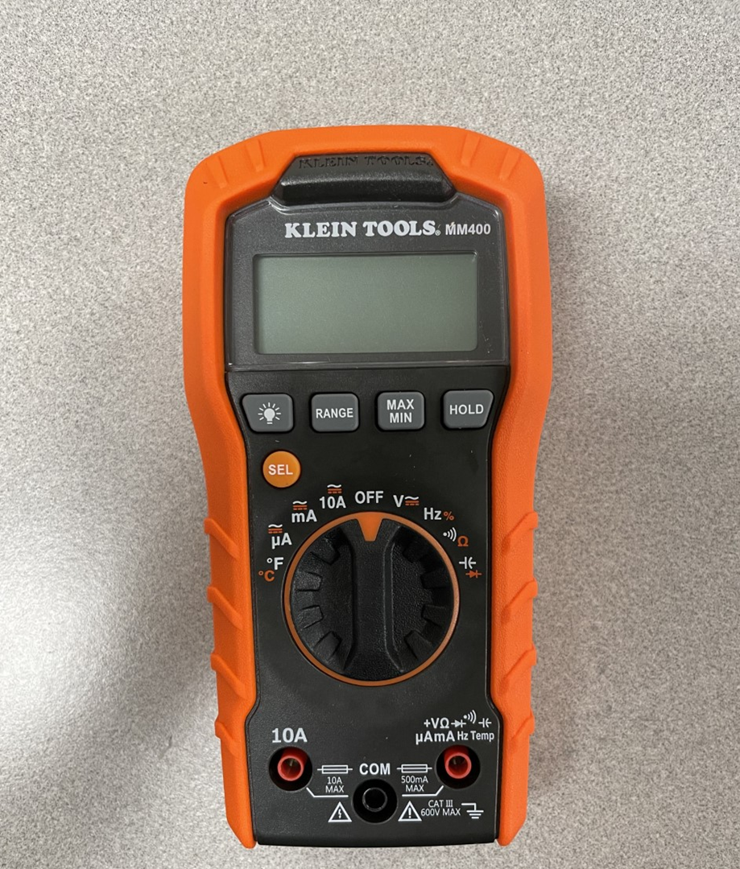

Below are photos of some of the DC power supplies in the lab. One can set a fixed voltage or a fixed current on these power supplies. Remember not to exceed 100 mA when setting the current.

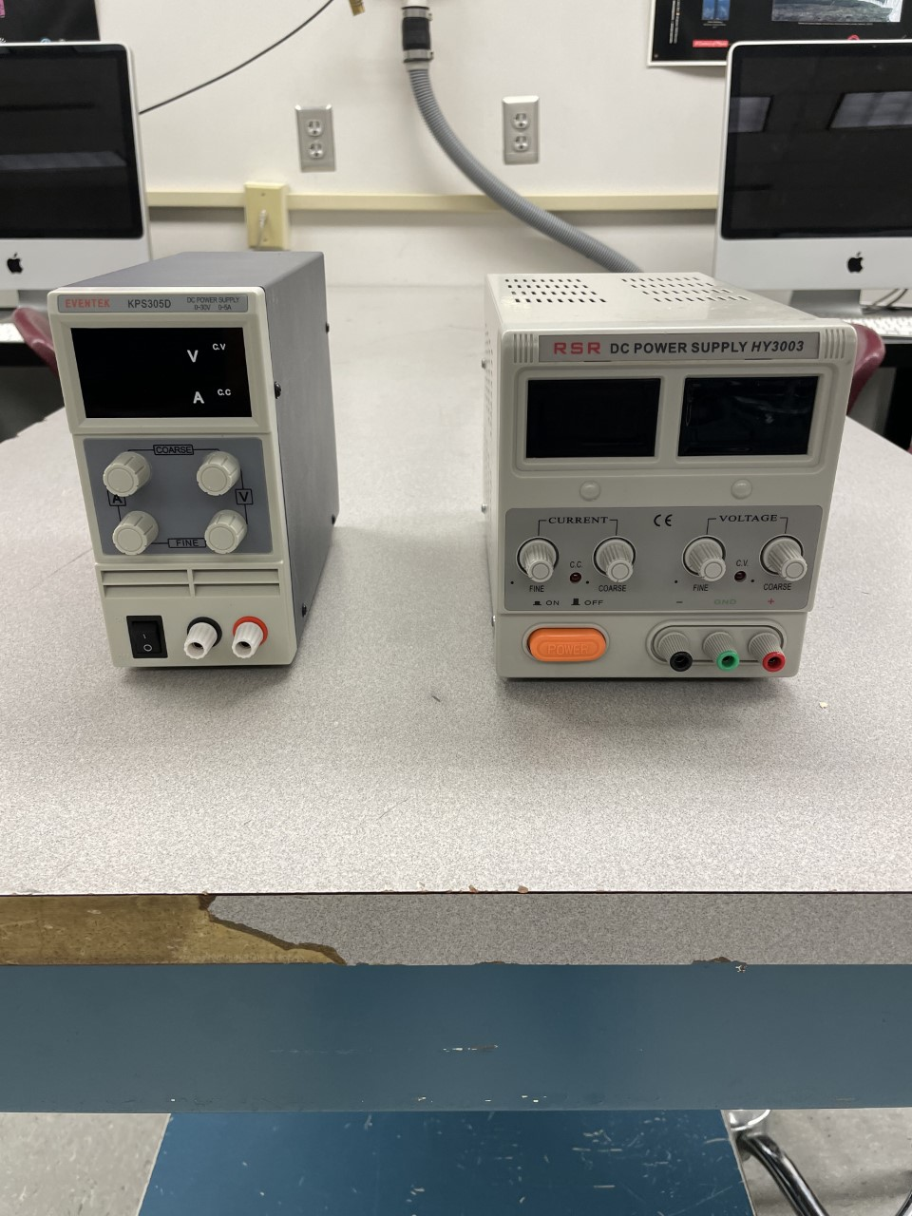

Finally, below are photos of resistors, along with a color code to determine the value of the resistance.

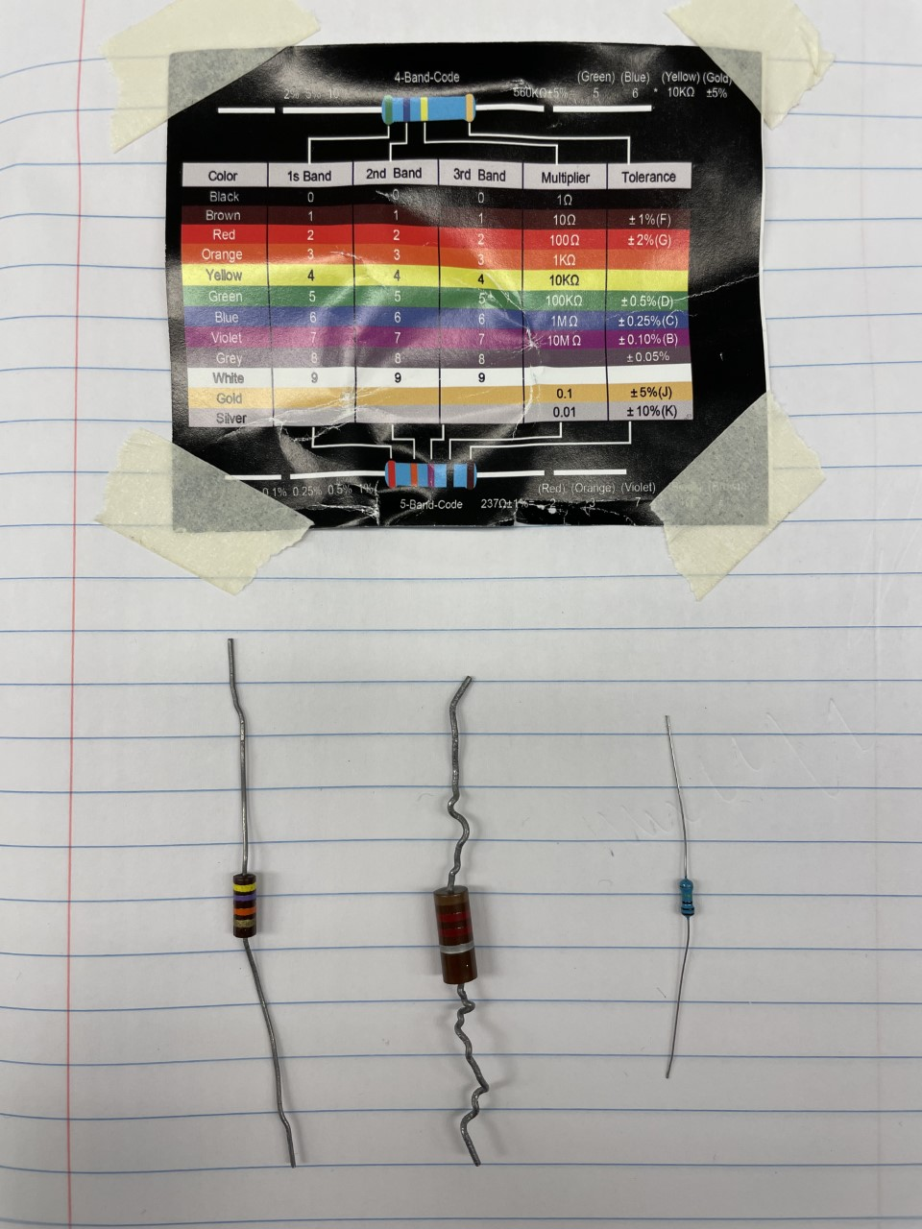

**Activity I – Complete these exercises with the multimeter.**

* Exercise 1: Measure the voltage of at least 3 different batteries.
* Exercise 2: Measure the voltage across the phone charger.
* Exercise 2: Measure the resistance of at least 3 different resistors.
* Exercise 4: Measure the current for 9 combinations of batteries and resistors (3 batteries and 3 resistors).

**Activity 2 – Complete these exercises with the D.C. power supply.**

* Exercise 1: Choose 1 resistor and measure the current through it for 5 different voltages.
* Exercise 2: For the same resistor, measure the voltage across it for 5 settings of the current.